
Student Name:_______________________

Eastern Goldfields College
Mathematics Applications U3&4 2018

Investigation 1 - Part B Validation
Working Time: 50 minutes | Calculators permitted. Total Marks: 43 (3+40)

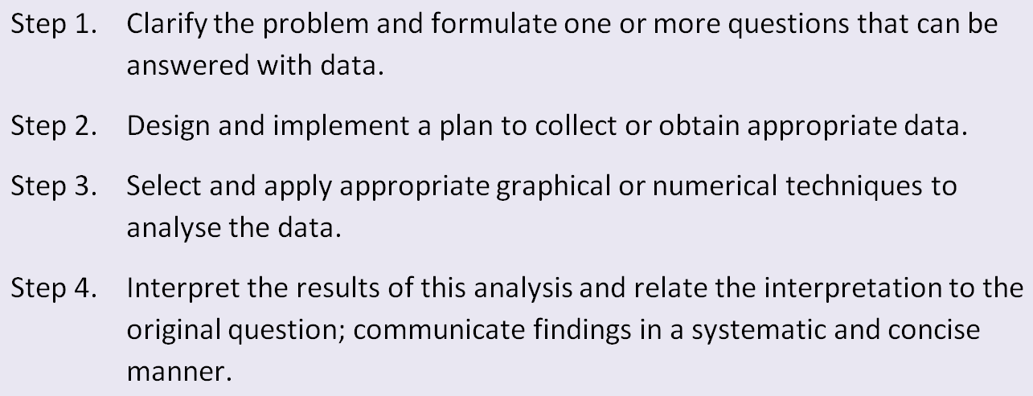

Scenario 1 [11 marks]
The manager of a furniture store noticed that most of the people who came to buy a television on one particular Friday were aged between 60 and 70 years old. He was thinking of the types of televisions that he should stock and wondered if he should order more of the types of sets purchased by his older customers. He decided to conduct some market research to investigate the idea that “the older adults became the more television they watched”

Three questions were posed for the investigation.
- Do pensioners watch more television than students?
- Do adults spend more time watching television as they get older?
- Do adults watch more television shows as they get older?
Question 1 (3 marks: 1, 1, 1)
- Give one reason why the first question is not the most suitable for this investigation. (1)

- Give one reason to justify why question 3 is better than question 2. (1)

- The question selected for the investigation was question 2. Select one word or phrase that could be misinterpreted or that might need to be explained or clarified. Explain your selection. (1)

Question 2 (8 marks: 1, 2, 1, 2, 2)
The two variables chosen for the investigation were age and time spent watching television?
- What further specification needs to be made for the variable time spent watching television. (1)
- Which is the response variable? Explain your decision. (2)
- Given that you want to collect data from adults of varying ages, what rounding would you apply for the variable age? (1)
- Give two reasons why it would not be useful to ask the adults to nominate the time they spent watching television to the nearest minute. (2)
- A scatter graph would be suitable to show the relationship between age and time spent watching television. Which variable should be placed along the horizontal axis? Explain your decision. (2)

Scenario 2 [6 marks]
Question 3 (6 marks)
Students in Year 12 have decided to investigate the relationship between the amount of money that students earn each week and the amount they spend on the Year 12 school dance. They will ask each student two questions.
How much money did you earn from paid employment last week?
How much did you spend at the school canteen last week?
Design and describe a process for collecting the data. In your design, address the following features:
- number of students to survey (1)
- process of selection of students to participate in the survey (2)
- time and date on which survey could occur (1)
- place for the survey to occur (1)
- method for recording data collected from students (1)

Scenario 3 [16 marks]
A student investigating the relationship between height and weight of men in a football team was given the statistics for 10 of the players.

Player | 1 | 2 | 3 | 4 | 5 | 6 | 7 | 8 | 9 | 10
Height | 194 | 200 | 183 | 175 | 190 | 195 | 185 | 180 | 174 | 186
Weight | 85 | 102 | 88 | 82 | 92 | 101 | 83 | 82 | 72 | 86

Question 5 (6 marks)
Represent the data above in a suitable graph. Label the graph appropriately.

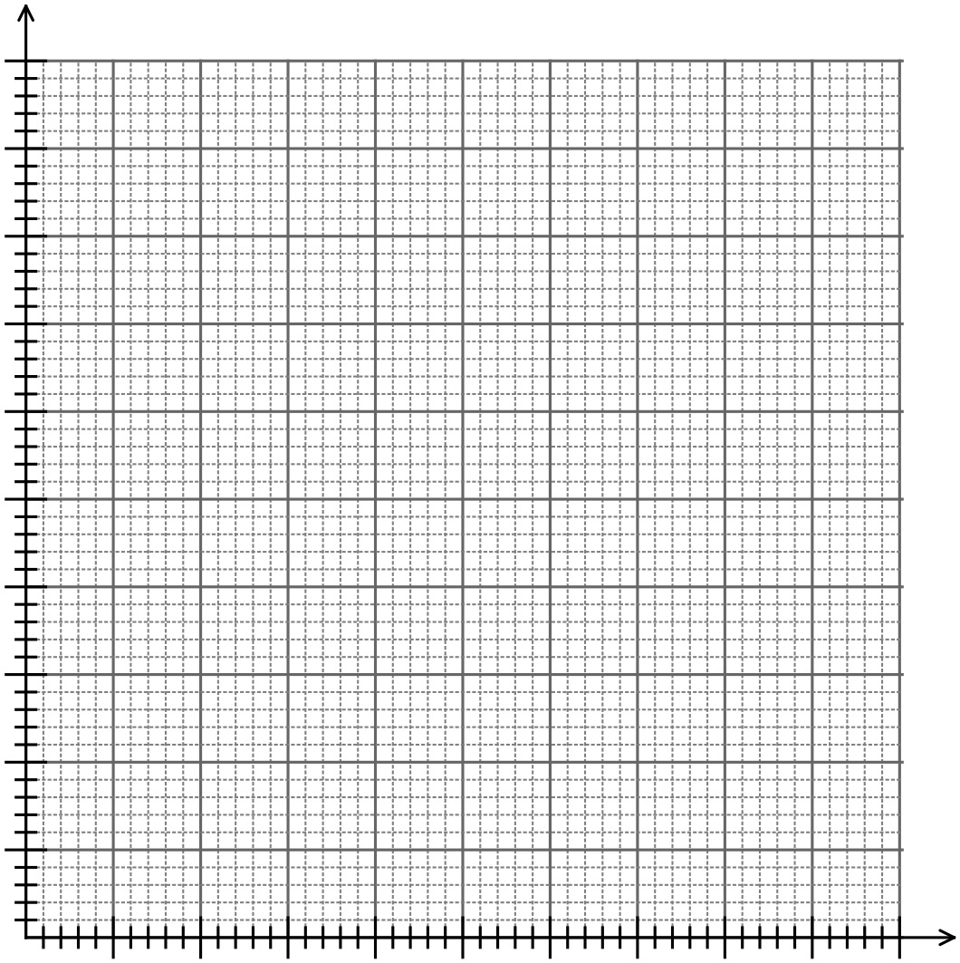

Question 6 (10 marks)
Use numerical techniques to analyse and determine the relationship between height and weight of men in a football team.

Scenario 4 [7 marks]

Question 7 (7 marks)
There has been an increase in the number of accidents involving cyclists aged 20-30 years throughout Australia and it has been suggested that the earlier a person learns to ride a bicycle the less likely they are to have an accident. Summarise the process you could use to implement the statistical investigation process to determine if there is a relationship between the number of accidents for cyclists aged 20-30 years and the age at which they learned to ride a bicycle.

~ END OF VALIDATION ~

